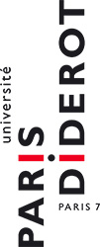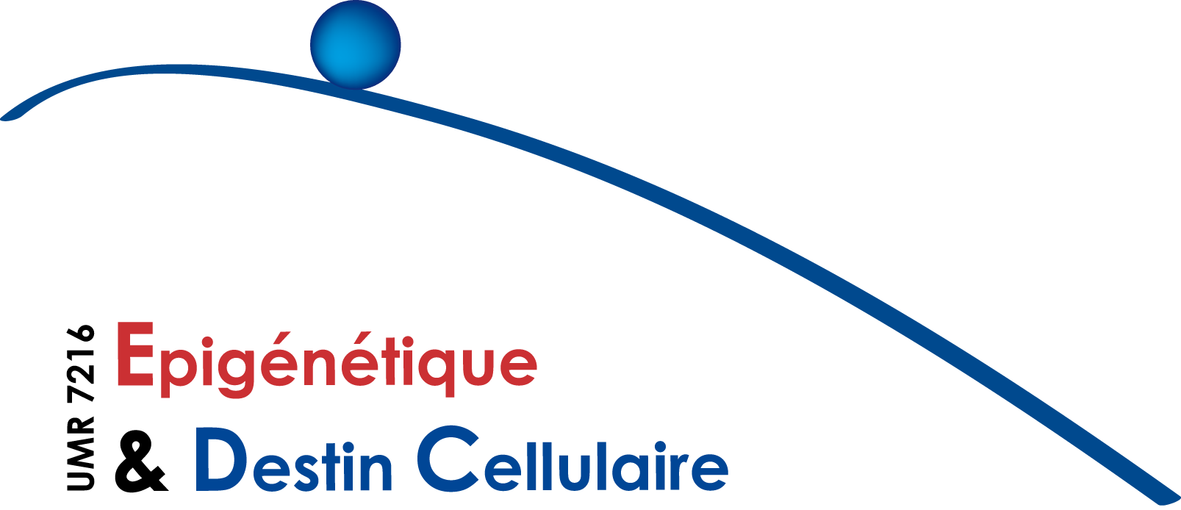

I N F O R M A T I O N S E M I N A I R E E P I G E N E T I Q U E :

Mercredi 13 Avril 2016 à 11h

Laurent Nguyen
Laboratory for molecular regulation of neurogenesis at the GIGA-Neurosciences Unit,
University of Liège, Belgium
Invité par Valérie Mezger
A dynamic unfolded protein response contributes to the control of cortical neurogenesis
Laguesse, S., Creppe, C., Nedialkova, D., Prévot, P.-P., Borgs, L., Huyseune, S., Franco, B., Duysens, G., Krusy, N., Lee, G., Thelen, N., Thiry, M., Close, P., Chariot, A., Malgrange, B., Leidel, S., Godin, J., and Nguyen, L. : A dynamic unfolded protein response contributes to the control of cortical neurogenesis Dev Cell 2015 35: 553-567
Volvert, M.-L., Prévot, P.-P., Close, P., Laguesse,S., Pirotte, S., Hemphill, J., Rogister, F., Kruzy, N., Sacheli, R., Moonen, R., Deiters, A., Merkenschlager, M., Chariot, A., Malgrange, B., Godin, J., and Nguyen, L. : MicroRNA Targeting of CoREST Controls Polarization of Migrating Cortical Neurons, Cell Rep 2014 7: 1168-83
Avila, A., Vidal, P.M., Dear, T.N., Harvey, J.H.., Rigo, J.-M., and Nguyen, L. : Glycine receptor α2 subunit activation promotes cortical interneurons migration. Cell Rep 2013 21: 1696-1708
Godin, J., Thomas, N., Laguesse, S., Malinouskaya, L., Close, P., Malaise, P., Purnelle, A., Raineteau, O., Campbell, K., Fero, M., Moonen, G., Malgrange, B., Chariot, A., Metin, C, Besson, A., and Nguyen, L.: p27Kip1 is a microtubule-associated protein that promotes microtubule polymerisation during neuron migration. Dev Cell 2012 23: 729-44.
Creppe, C., Malinouskaya, L., Volvert, M.-L., Gillard, M., Close, P., Malaise, O., Laguesse, S., Cornez, I., Rahmouni, S., Ormenese, S., Belachew, S., Malgrange, B., Chapelle, J.-P., Siebenlist, U., Moonen, G., Chariot, A. and Nguyen, L. : Elongator Controls the Migration and Differentiation of Cortical Neurons through Acetylation of Alpha Tubulin. Cell 2009 132: 551-564
Ce séminaire a lieu dans la salle de séminaires de l’Institut Jacques Monod (RB-18B). Bâtiment Buffon - 15 rue Hélène Brion. Paris 13e
Contact : sophie.polo@univ-paris-diderot.fr

Biosketch
Laurent Nguyen is researcher for the FRS-FNRS. After completing a PhD in neurobiology under the direction of Prof. Gustave Moonen (1999-2003) at the University of Liège (ULg), Laurent Nguyen received an EMBO LTF and completed a postdoctoral stage in the laboratory of Dr. François Guillemot at the National Institute for Medical Research in London (2003-2006). Laurent Nguyen is currently the head of the Laboratory for molecular regulation of neurogenesis at the GIGA-Neurosciences Unit, hosted by the ULg. With his group, he is studying the cellular and molecular mechanisms that regulate the development of the cerebral cortex. His research has been rewarded with several scientific prizes. He has authored several publications, including some prestigious scientific journals.

